Chapter 18, Problem 38.

Using Fig. 18.40, design a problem to help other students better understand using Fourier transforms to do circuit analysis.
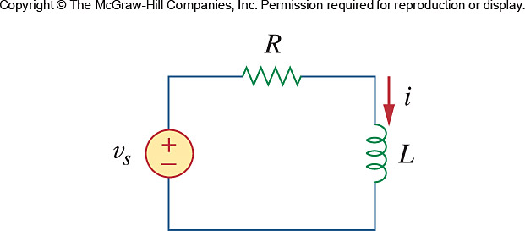

Figure 18.40
For Prob. 18.38.

